

CAPSTONE PROJECT REPORT
Report 1 – Project Introduction

– Ho Chi Minh, September 2026 –
Table of Contents
I. Record of Changes 3
II. Project Introduction 4
1. Overview 4
1.1 Project Information 4
1.2 Project Team 4
2. Product Background 4
3. Existing Systems 4
3.1 Wing 4
3.2 Locker-based parcel systems 4
4. Business Opportunity 4
5. Software Product Vision 5
6. Project Scope & Limitations 5
6.1 Major Features 5
6.2 Limitations & Exclusions 6

I. Record of Changes
Date | A*  M, D | In charge | Change Description
12/09/2026 | A | Nguyễn Quốc Bảo Huy | Initial Report 1: project information, project team, product background, existing systems, business opportunity, software product vision, project scope and limitations.
21/09/2026 | M | Trương Nguyễn Thái Bình | Refined Section 2 (Product Background) and Section 3 (Existing Systems: Wing and locker-based parcel systems); separated Technician into Locker Technician and Drone Technician roles.
07/10/2026 | M | Lê Thị Yến Vi | Updated Drone Fleet Management (FE-07), Drone Dispatch (FE-08), Flight Tracking & Simulation (FE-09) and Drone Maintenance & Incidents (FE-11) to include home pickup, loading confirmation, live MAVLink telemetry and parcel-drop recovery.
13/10/2026 | M | Trần Kim Nhã | Updated Payment & Refund (FE-12) and limitation LI-5 to use SePay bank transfer (VietQR) only and admin bank-transfer refunds, removing MoMo, VNPay and cash payments.
24/10/2026 | M | Trương Nguyễn Thái Bình | Updated Authentication (FE-01), Parcel Deposit & Retrieval (FE-06), Locker Maintenance (FE-10) and Loyalty & Promotion (FE-13) with phone OTP login, delegated pickup, PENDING_CHECK box status and point-to-voucher redemption.
28/10/2026 | M | Trần Kim Nhã | Updated Real-Time Monitoring & IoT (FE-14), AI Assistant (FE-15) and Business Configuration (FE-17) with MQTT cabinet commands, order-aware RAG queries and configurable weather and flight rules.
07/11/2026 | M | Lê Thị Yến Vi | Updated Report 1 to match the current system: software type, product background, business opportunity and software product vision; rewrote major features as FE-01 to FE-20 (added FE-19 Locker Kiosk and FE-20 Multilingual & Legal) and redrew the major features diagram; rewrote limitations as LI-1 to LI-7 (added LI-7 flight restrictions); corrected the table of contents entries of section 3.
*A - Added M - Modified D - Deleted

II. Project Introduction

1. Overview

1.1 Project Information
- Project name: Drone Delivery and Smart Locker Management System
- Project code: DDSLMS
- Group name: GFA26SE32
- Software type: Web, Mobile App and IoT (self-service locker kiosk and controllers)

1.2 Project Team
Full Name | Role | Email | Mobile
Đặng Ngọc Minh Đức | Lecturer | Ducdnm2@fpt.edu.vn
Đỗ Hữu Tiến | Lecturer | Tiendh6@fpt.edu.vn
Lê Thị Yến Vi | Leader | Viltyse182544@fpt.edu.vn | 0985868349
Trần Kim Nhã | Member | Nhatkse182290@fpt.edu.vn | 0933102278
Trương Nguyễn Thái Bình | Member | Binhtntse182370@fpt.edu.vn | 0366452201
Nguyễn Quốc Bảo Huy | Member | Huynqbse180211@fpt.edu.vn | 0911649183

2. Product Background
Last-mile delivery is one of the most time-consuming and costly stages of e-commerce logistics. As online shopping continues to grow, both urban and suburban customers increasingly expect fast, contactless, and predictable delivery experiences. Smart Locker networks have already been adopted in residential areas, universities, and commercial centers as a secure way to store and hand over parcels without requiring the recipient and courier to meet in person.
At the same time, drone delivery has moved from an experimental technology to an operational one. Commercial operators now run thousands of autonomous drone deliveries per day, using either vertical-landing drones that lower packages to the ground or tethered systems that release a package from altitude and let it navigate the final few meters on its own. These deployments show that autonomous aerial delivery is technically mature enough to serve as a real transportation layer for short-distance logistics.
However, the teams building these drone networks and the teams building Smart Locker infrastructure have largely worked in isolation. Most existing drone-delivery platforms concentrate on flight control, routing, or simulation, while most locker systems focus only on compartment access and notification. There is no widely available, integrated software platform that lets an operator manage delivery orders, a fleet of drones, drone maintenance, and a network of Smart Lockers from a single system, with real-time visibility into every stage of the process.
This gap was the starting point for the Drone Delivery and Smart Locker Management System (DDSLMS). The group's supervisor and members recognized that a university-scale capstone project could contribute a working, integrated management platform — built around a Smart-Locker-to-Smart-Locker delivery model.

3. Existing Systems

3.1 Wing
Wing is a commercial drone-delivery service operated by Alphabet's Wing Aviation LLC. The system provides a fully automated order-to-delivery flow, including drone selection, route planning, and coordination between multiple drones, while its API-first integration model allows partner businesses to connect drone delivery with their existing ordering systems. Certified pilots can supervise multiple drones simultaneously, and the network is designed to scale from small operations to more than a thousand deliveries per day. Its main strengths include mature automated routing, a strong safety record, easy API integration, and scalable operations. However, Wing mainly focuses on the drone and delivery side and does not provide an integrated Smart Locker or maintenance-management layer.

3.2 Locker-based parcel systems (e.g., Amazon Hub Locker, patented drone-activated lockers)
Separately from drone operators, several parcel-locker systems already exist for ground-based deliveries, and patented designs describe lockers with doors that open automatically when they detect an approaching drone and close once the package is deposited. These designs confirm that drone-to-locker handoff is technically feasible, but they describe hardware behaviour only and do not include an order-management, fleet-management, or monitoring platform on top of the locker network.
Taken together, the reviewed systems confirm that drone delivery and Smart Locker technology are each independently viable, but no publicly documented system combines delivery management, drone fleet and maintenance management, real-time monitoring, and Smart Locker operations into a single software platform — which is the gap DDSLMS is intended to address.

4. Business Opportunity
The rapid growth of e-commerce and food delivery has increased pressure on last-mile logistics, particularly for short-distance deliveries within university campuses, residential compounds, or commercial districts, where ground traffic, parking constraints, and staffing costs can make frequent small deliveries expensive. Commercial drone operators have demonstrated that autonomous aerial delivery can reduce delivery time and avoid road congestion, while smart locker networks have shown that unattended and secure pickup can improve convenience and reduce missed-delivery attempts.
What is currently missing — and what represents the opportunity for this project — is a single, integrated operations system that enables a logistics provider to manage the full lifecycle of drone-and-locker deliveries. This includes creating and tracking orders, assigning suitable drones to orders based on battery level, availability and weather conditions, monitoring the drone fleet and lockers in real time, maintaining lockers and drones through incident handling and scheduled inspections, and providing customers and operations staff with quick answers from operating documents through an AI assistant.
Such a system would benefit university campuses, residential compounds, and small commercial hubs that want to pilot drone-and-locker delivery without depending on a large, closed commercial network. Its demonstration mode, which simulates drone flight stages, also lets operators rehearse the full delivery process before flying real drones, providing value both to operators seeking efficiency improvements and to the research community studying smart logistics.

5. Software Product Vision
For operators who want to run contactless, drone-based last-mile delivery between the Smart Lockers of their network, the Drone Delivery and Smart Locker Management System (DDSLMS) is an integrated web, mobile and self-service kiosk platform that manages locker and drone delivery orders, dispatches and tracks a fleet of drones with battery, weather and pre-flight safety checks, operates Smart Locker compartments through PIN/QR-based pickup, keeps lockers and drones maintained through incident tickets and periodic inspections, and gives customers and staff AI-assisted answers grounded in operating documents. Unlike existing drone-delivery services and locker systems, which operate as separate, closed systems, DDSLMS unifies delivery, fleet, maintenance, and locker operations into one real-time platform, so that operators can plan, monitor, and improve every stage of a delivery from a single dashboard.

6. Project Scope & Limitations

6.1 Major Features

FE-01: Authentication
  - Sign Up
  - Sign In With Email/Password
  - Sign In With Phone Number (OTP)
  - Sign In With Google
  - Sign In With Email OTP
  - Admin Two-Factor Authentication
  - Forgot Password
  - Change Password
  - Sign Out

FE-02: Role/Permission Management
  - View System Roles
  - Change User Role
  - Role-Based API Access
  - Assign Technician To Locker/Drone

FE-03: User Management
  - View Users
  - Create Staff Account
  - View User Detail
  - Update Profile
  - Lock/Unlock Account
  - Delete Account (Soft Delete)

FE-04: Order Management
  - Create Send Order
  - Create Rental Order
  - Create Drone Delivery Order
  - View Orders
  - Track Order Timeline
  - Extend Rental
  - Cancel Order
  - Rate Order/Submit Complaint

FE-05: Locker Management
  - View Lockers On Map
  - View Locker Layout
  - Manage Lockers
  - Manage Compartments
  - Assign Controller To Locker
  - Emergency Unlock
  - Manage Stores

FE-06: Parcel Deposit & Retrieval
  - Deposit Parcel
  - Generate Pickup PIN/QR
  - Send Pickup Code To Receiver
  - Retrieve Parcel By PIN/QR
  - Delegate Pickup
  - Change Pickup PIN
  - Pay Overdue Fee

FE-07: Drone Fleet Management
  - View Drones
  - Add Drone
  - Update Drone Status
  - Assign Controller To Drone
  - View Drone Telemetry
  - Delete Drone

FE-08: Drone Dispatch
  - Assign Home Pickup
  - Collect Parcel At Home
  - Accept Drone Order
  - Confirm Parcel Loading
  - Launch Drone
  - Report Failed Flight

FE-09: Flight Tracking & Simulation
  - Track Delivery Stages
  - View Flight Map
  - Simulate Flight (DEMO Mode)
  - View Flight Data

FE-10: Locker Maintenance
  - Report Locker Fault
  - Claim Ticket
  - Extend SLA
  - Move Parcel To Another Compartment (New PIN)
  - Complete Ticket
  - Periodic Locker Inspection
  - Rate Ticket

FE-11: Drone Maintenance & Incidents
  - Periodic Drone Inspection
  - Handle Drone Ticket
  - Report Parcel Drop
  - Recover Dropped Parcel
  - Resolve Drop Incident

FE-12: Payment & Refund
  - Pay By VietQR (SePay)
  - Pay Additional Charges
  - Request Refund
  - Process Refund
  - View Transaction History

FE-13: Loyalty & Promotion
  - Earn Loyalty Points
  - View Points & Tier
  - Pay With Points
  - Redeem Points For Voucher
  - Manage Promotions
  - Apply Voucher

FE-14: Real-Time Monitoring & IoT
  - Send Unlock Command (MQTT)
  - Monitor Controller Status
  - Restart Locker Controller Remotely (Locker Technician)
  - Receive Drone Telemetry
  - Real-Time Updates (WebSocket)

FE-15: AI Assistant (RAG)
  - Upload Document
  - Ask Assistant
  - Ask About My Orders
  - View Conversation History

FE-16: Notification
  - View Notifications
  - Push Notification (FCM)
  - Email Notification
  - SMS Notification
  - Broadcast Notification
  - Remind Customers Of Overdue Pickup Or Expired Rental
  - Remind Technicians Of Due Inspections

FE-17: Business Configuration
  - Configure Prices
  - Configure Deadlines & Fees
  - Configure Drone Rules
  - Configure Weather & Flight Pause
  - View Setting Audit Log

FE-18: Dashboard & Reports
  - View Dashboard
  - View Revenue Reports
  - Search Orders & Payments
  - Manage Feedback
  - Monitor SLA & Technicians

FE-19: Locker Kiosk
  - Retrieve Parcel
  - Sign In With OTP
  - Quick Register
  - Rent Compartment
  - Pay By VietQR
  - End Rental
  - Report Fault

FE-20: Multilingual & Legal
  - Switch Language (VI/EN)
  - Translate Server Messages
  - Accept Terms Of Service

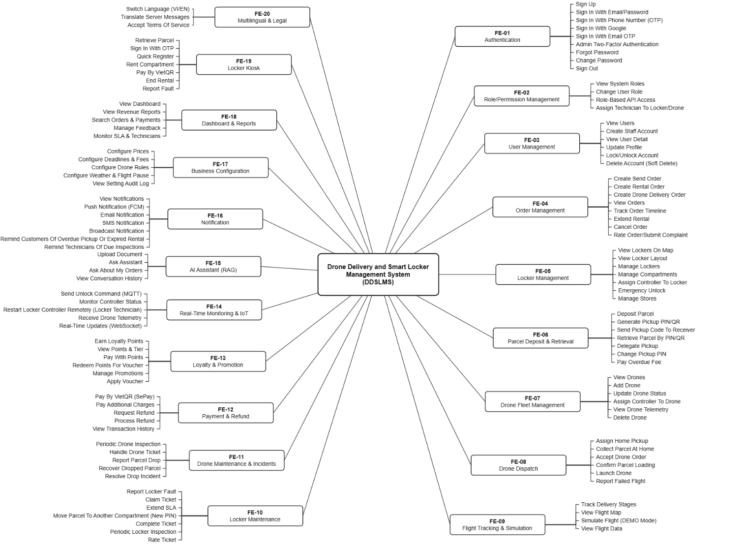
Figure 6.1: Major features of DDSLMS

6.2 Limitations & Exclusions
- LI-1: Compartments have no weighing scale or climate control; parcel size depends on the compartment type (Standard, XL, Drone).
- LI-2: Each locker is controlled by a Raspberry Pi 4 through GPIO and MQTT, so unlocking a compartment needs a network connection.
- LI-3: Drone flights are launched and supervised by drone technicians; autonomous route planning, sense-and-avoid and airspace permits are out of scope.
- LI-4: Drones only fly between lockers with a landing pad, within the maximum distance (5 km by default, configurable by the Admin); home pickup is done by drone technicians.
- LI-5: Payment is only by VietQR bank transfer (SePay); cards, e-wallets, cash and an in-app customer wallet are not supported, and refunds are transferred manually by the Admin.
- LI-6: The AI Assistant only answers from uploaded documents and the user's own orders; it cannot perform any action.
- LI-7: Flights are blocked outside flight hours, in bad weather, or when the Admin pauses flights.

